Team 6 - Gamification
Clayton Barnett
Omar Ahmed
Alejandro Medina
Jackie Li
Ansugan Subramaniam

Summary
This report summarizes the gamification team’s contribution to the CampusConnect app. This includes a description of the project layout, the key contributed features - a points system, rewards management, and user leaderboard - and some details about the development process and how it integrates with the rest of the app.

User Guide

Project Layout
The layout of the project is relatively simple and follows the standard Next.JS framework as well as React.JS conventions. The following list outlines the project’s layout, including descriptions of important files and directory structure.

- docs/ - Includes README docs for each group. E.g. 6_README.md
- migrations/ - Database migration scripts
- scripts/ - General scripts to run
- src/
  - app/ - File based routing, includes all UI pages
    - api/rewards/ - Rewards endpoint for redeeming/adding rewards
    - leaderboard/ - Leaderboards page to see top users by points
    - my-rewards/ - A page to list a user’s redeemed rewards
    - rewards/ - The rewards catalog page
  - components/ - General React components
  - database/ - Application database schema, as well as query functions
  - lib/ - General library functions e.g. authorization API
  - testing/ - Testing functions
- docker-compose.yml - Container for local database environment.
- package.json - Project dependency list

Features
The gamification team was tasked with implementing the following features:

Point System
The Points System offers an organized, measurable method of rewarding students for participating in events. The system enables event planners to award points and students to create a history of their earned and spent incentives.
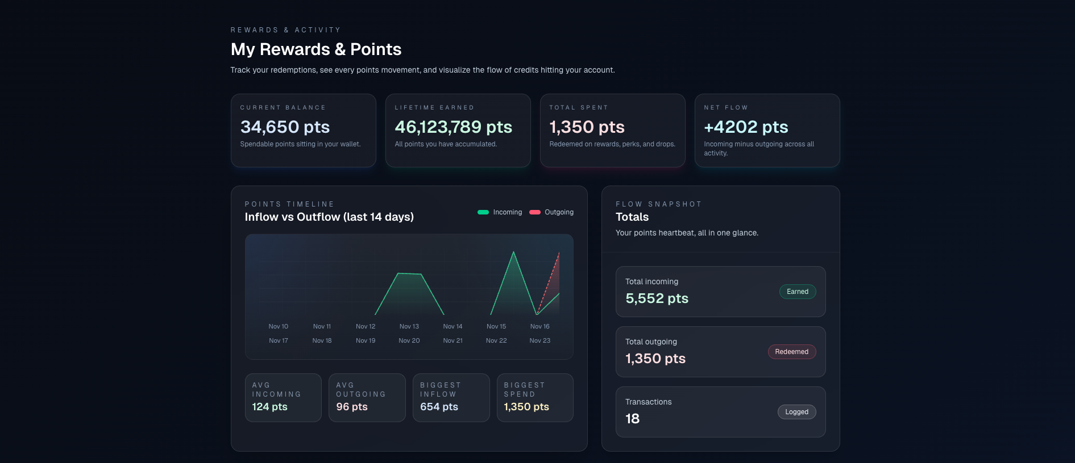

Figure 1: Rewards & Point Transactions

- Independent Points Profile

Each student now has a dedicated points profile that lives separately from the main user profile. This allows the rewards system to work independently without interfering with user authentication/personal details. This feature acts as the “wallet” for a user.

- Transaction for Points Activity

Within the design, the gamification team implemented a sub-feature that tracks every point-related action, including:

- Points earned from events
- Points spent on rewards
- Full historical traceability

This feature can be viewed from the user’s rewards page as a full financial statement.

- Event-Side Integration

To ensure that users are rewarded for attending events, the gamification team implemented a dedicated server-side function that allows external teams to call when a student attends an event. This function:

- Credits the student’s points profile
- Write a corresponding transaction
- And links the transaction to the corresponding event registered.

This gives external teams a clean and safe API to interact with the points system without knowledge of the gamification domain/internals.

Rewards Management
The rewards management system allows a user to turn their earned points into perks, like campus merchandise, while giving admins the tools to manage the available rewards and add to the catalog.

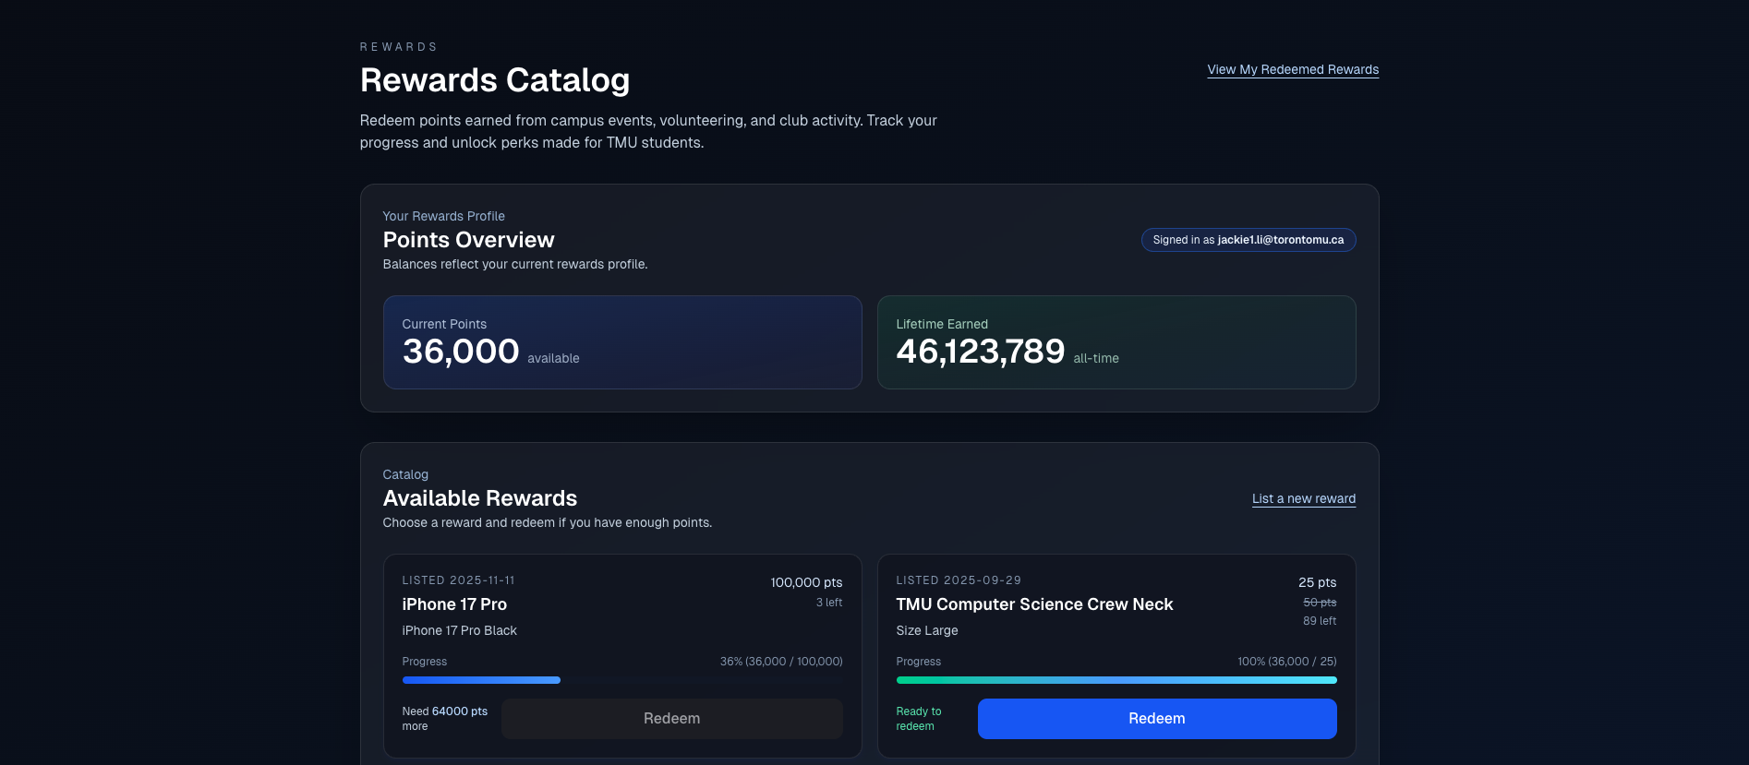

Figure 2: Rewards Catalog

- Reward Redemption - Students can redeem their accumulated points for any reward.
- Admin Management - Authorized admin users can add new rewards directly to the rewards page.
- Reward Browsing - Users can browse the rewards before redeeming them.

User Leaderboard
The user leaderboard displays each student’s all-time accumulated points, offering a clear view of their overall participation across events. It updates dynamically as points are earned, giving students a transparent and motivating way to track their long-term engagement.
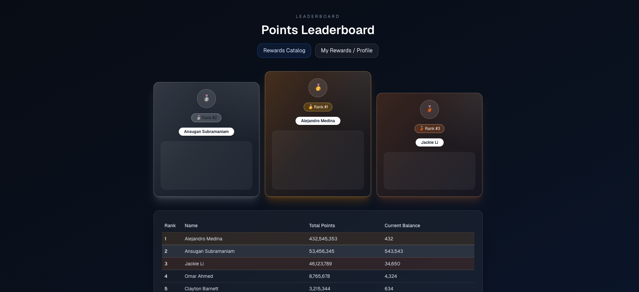

Figure 3: Points Leaderboard

Development

Version Control
The project utilized git for version control along with GitHub for collaboration. The following image is a list of commits made nearing the end of the project’s lifecycle.

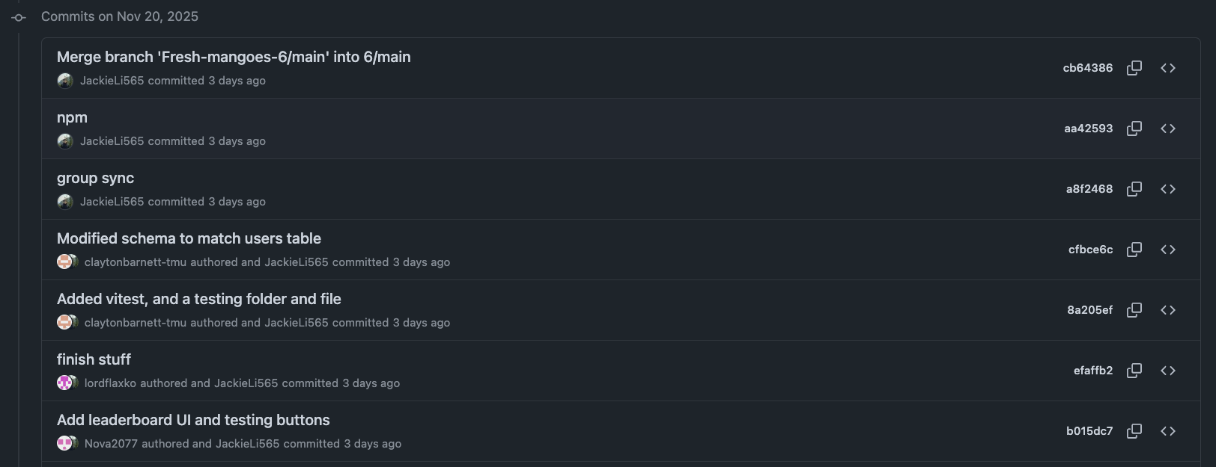

Figure 4: Project Commits

The project branch can be found using the following link: GitHub Repository Group 6

Logs & Issue Tracking
Our team utilized a local repository to track issues and tasks in our sub-project. The issues were created using GitHub’s issue feature, which mimicked our tasks and milestone documents in Assignment 1. The following screenshot contains a list of issues allocated to each team member.

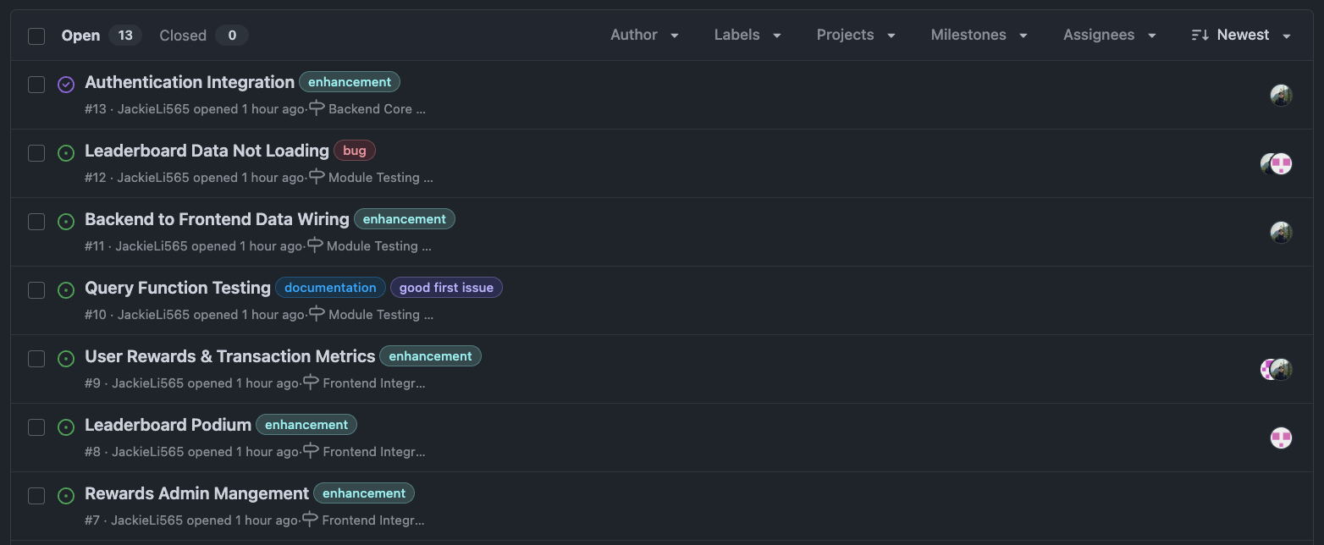

Figure 5: Issues

Progress logs, on the other hand, were tracked via lab sessions. Of the lab sessions, our team (group 6) attended each session for weekly updates on our team's project.

Supporting Documents
A technical document for the gamification team can be found in the following link: Group 6 Documentation

Code
The functionality of the code can be viewed via the presentation.

Quality
In terms of the code quality of the project, the codebase follows foundational practices such as:

- Schema/migration files with queries segmented into dedicated functions.
- UI logic uses React’s composability, separating server-driven pages from client-focused components
- Files and utilities related to the gamification group are properly named, making them easy to locate as the codebase is shared with multiple groups
- Naming conventions follow standard practice
- As well as the implementation of unit testing with a standardized framework

For more information regarding API specifications, our group's documentation can be found in the following link: Group 6 Documentation

Errors
During the development of our project, we as a group encountered situations where the application could error. For example:

- Only admins must add rewards
- A using redeeming rewards without enough points
- Reward listings must not be negative
- Etc…

To mitigate these edge cases, we implemented a defensive programming tactic where we assume possible edge conditions and implement code to ensure these cases never happen. In the odd cases that they do, the application prompts the user accordingly. Below is an example of an error message when an admin attempts to list a reward with a higher discount cost than the original cost:

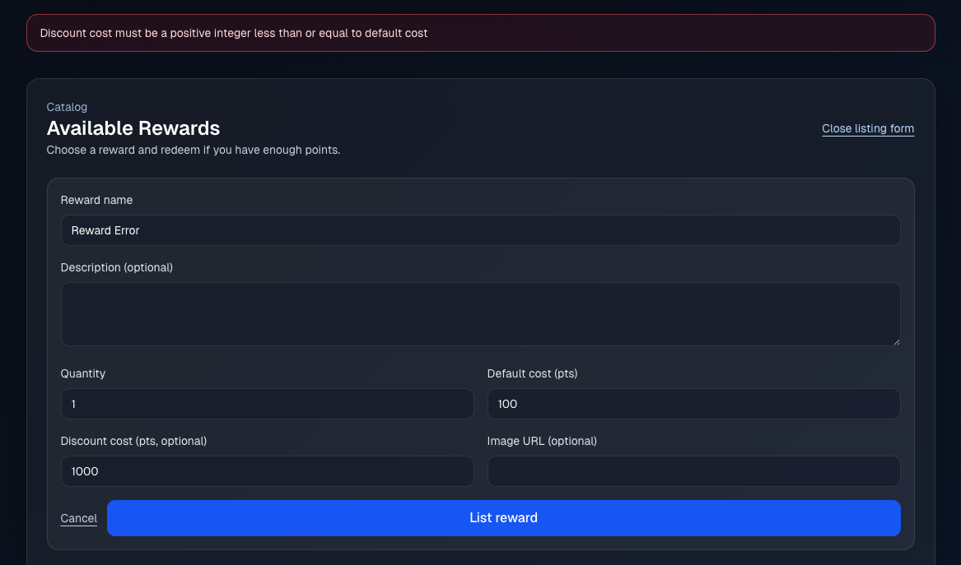

Figure 6: Error Message Mismatch

Integration
During the integration phase of the project, our group was tasked to integrate our feature with 3 teams:

- User Authentication
- Events Management
- User Dashboard

As a group, we were able to successfully integrate with the authentication team. This can be seen within the application based on the following two images:

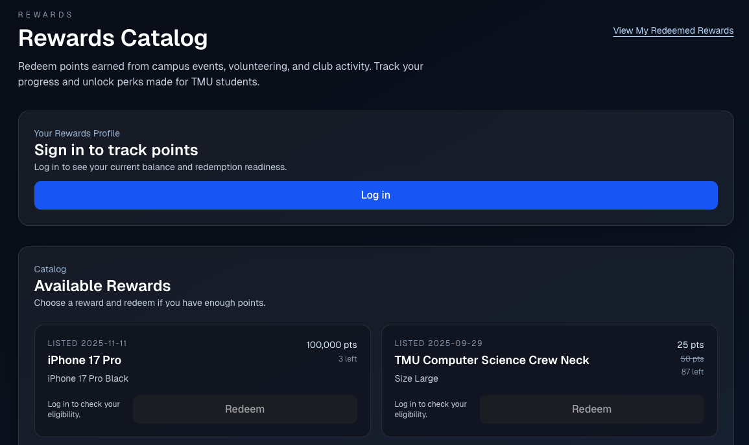

Figure 7: Unauthorized User

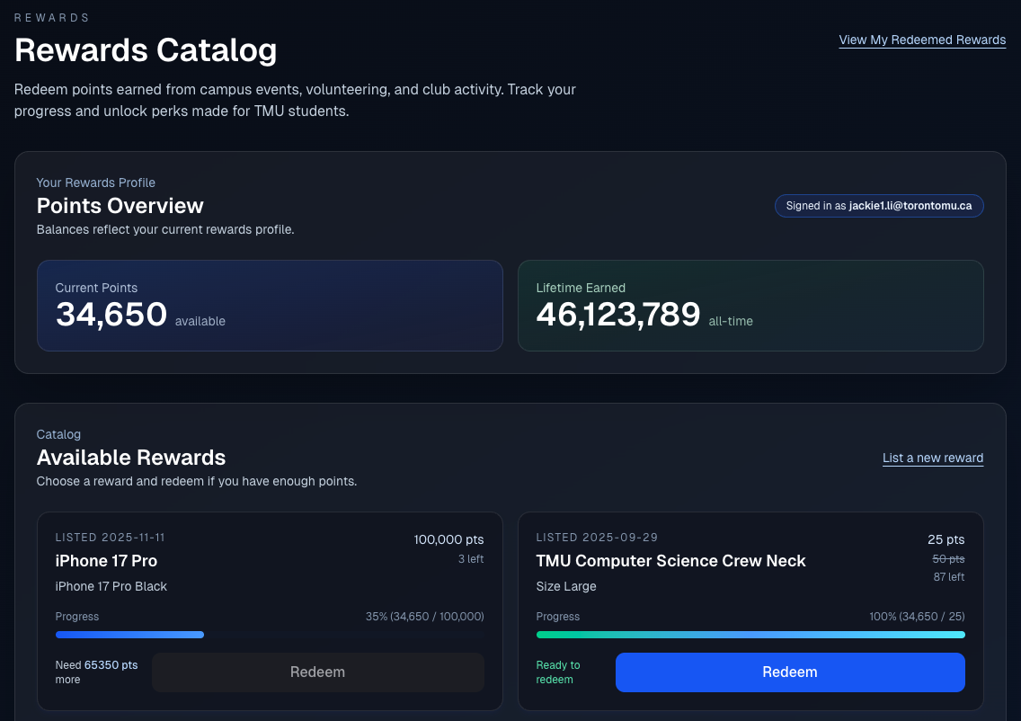

Figure 8: Authorized User

In Figure 1, it can be seen that the user has not logged in but is able to view available rewards; however, unable to redeem. Once the user has been authenticated via the login page built by the Authentication team, the points overview dashboard displays metrics of the current user. In the case of Figure 8, jackie1.li@torontomu.ca was successfully authenticated and authorized.

Integration of the Event Management and User Dashboard did not go as smoothly as the authentication team had hoped. Unlike authentication, the teams in question had to use our APIs to integrate with the system. Due to time constraints, we as a team were unable to integrate with the sub-projects promptly.

The integration between teams was streamlined through two key touchpoints.

- Events Management: Integrated with the points system by calling a server-side function that applies event-category logic to award the appropriate number of points.
- User Dashboard: Connected to the rewards catalog by routing users from the dashboard to the rewards page through a dedicated link.

